**INTERNET OF THINGS**

**JURUSAN TEKNOLOGI INFORMASI**

**Dosen**

**Noprianto S.Kom., M.Eng.**

**Dibuat Oleh :**

|  |  |
| --- | --- |
| **Dherisma Hanindita Utami** | **Meliusa Nora Hariyanti** |
| **2041720018** | **2041720084** |
| **07** | **13** |

|  |
| --- |
| **Dilta Febiana** |
| **2041720136** |
| **08** |

**TI 3G**

**POLITEKNIK NEGERI MALANG**

**2023**

**Kelompok 3**

**Pertemuan 5**

Project 1 : Running LED RGB

1. Hardware Preparation:

* NodeMCU x 1
* LED RGB x 1
* 220 ohm resistor x 3, optional
* Kabel Dupont (male to male)
* Micro USB cable x 1
* PC/laptop x 1
* Software Visual Studio Code

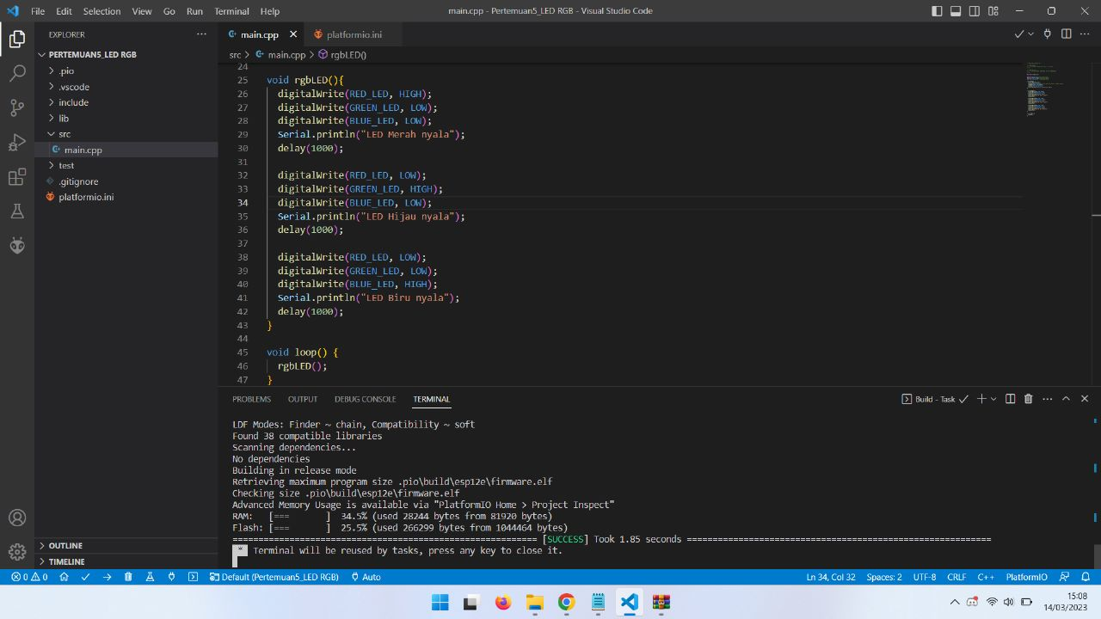

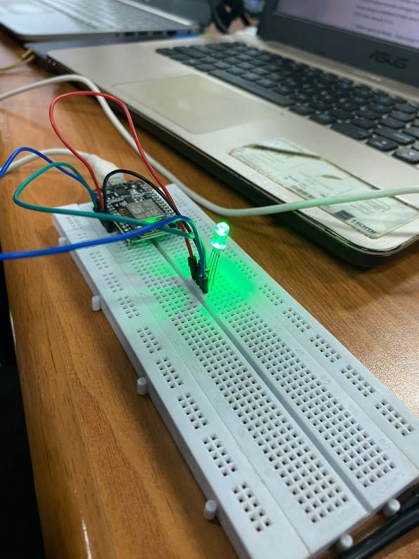 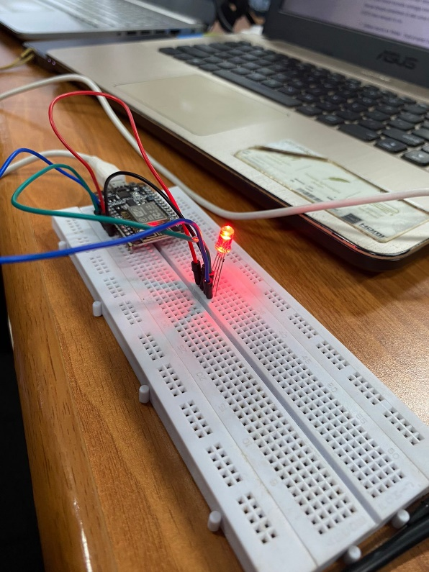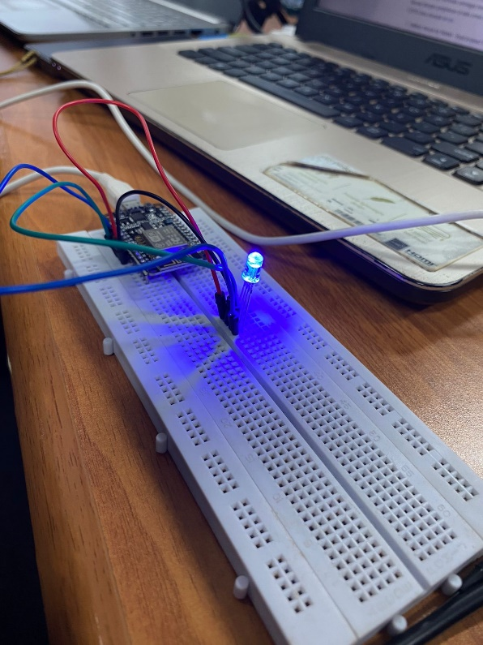

**Project Wokwi**

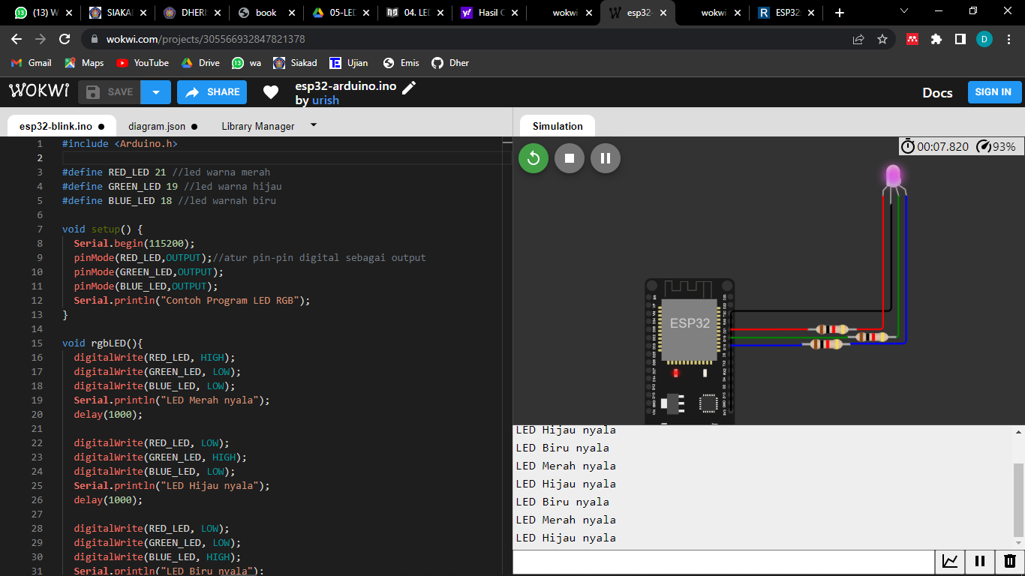

<https://wokwi.com/projects/305566932847821378>

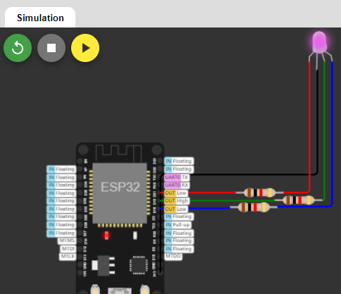

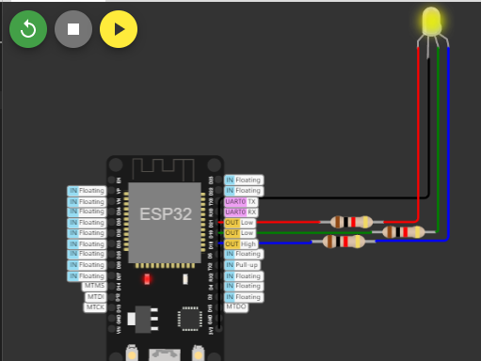

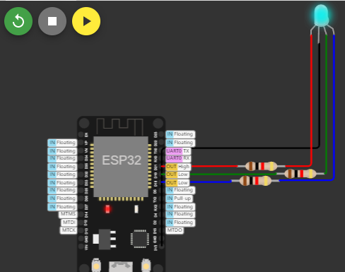

**Project 2 : SOS LED**

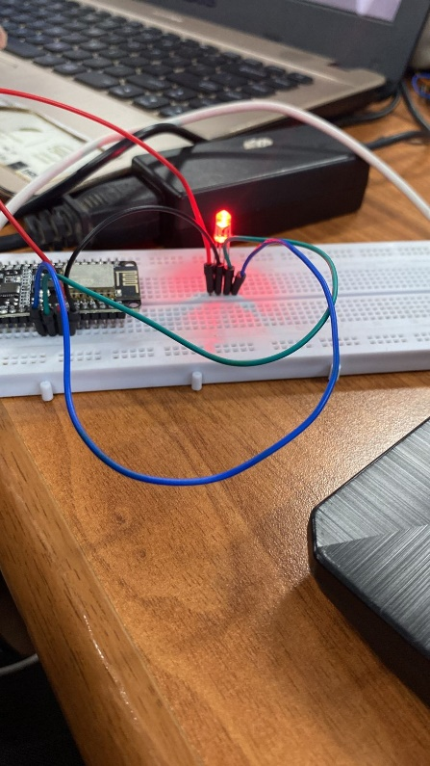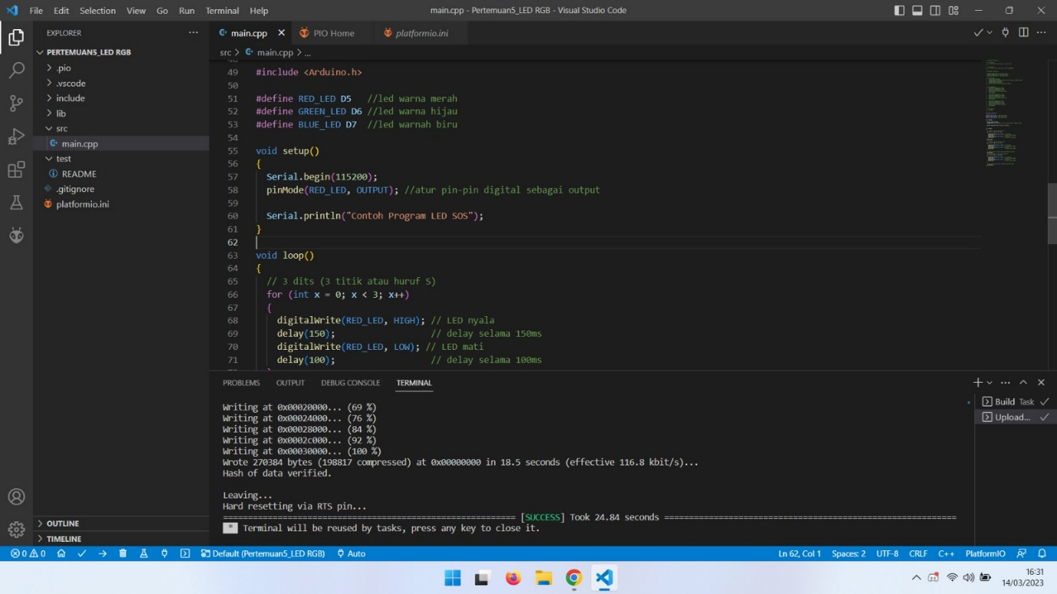

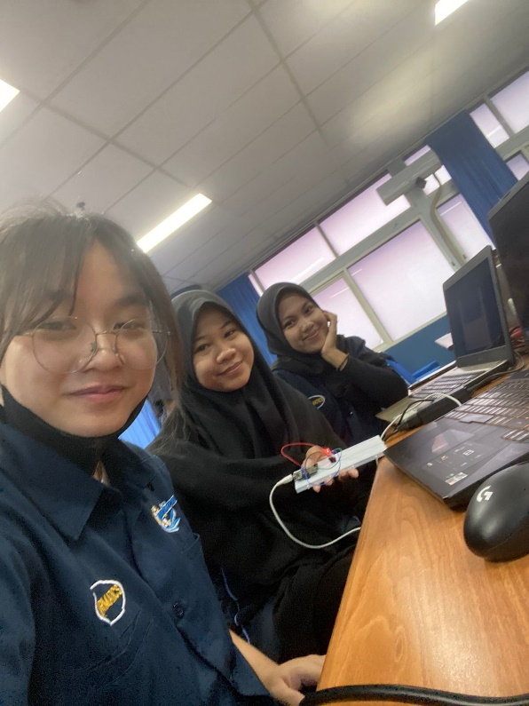

Laporan Tim

**Tugas**

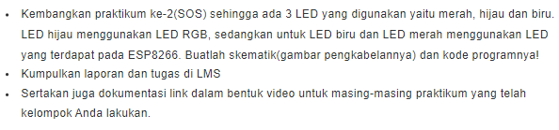

**Menggunakan cara 1A**

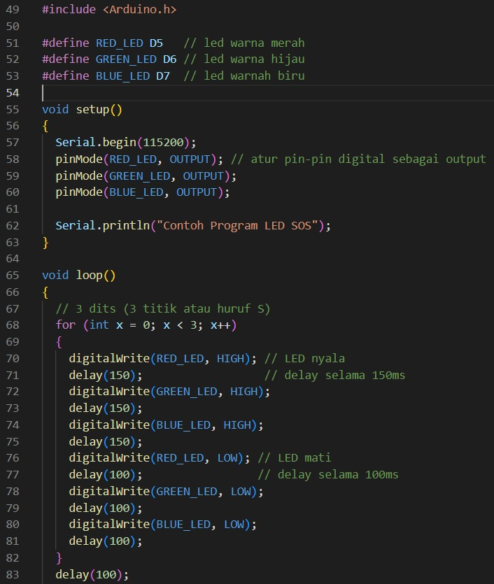

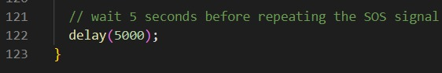

Skematik Pengkabelan

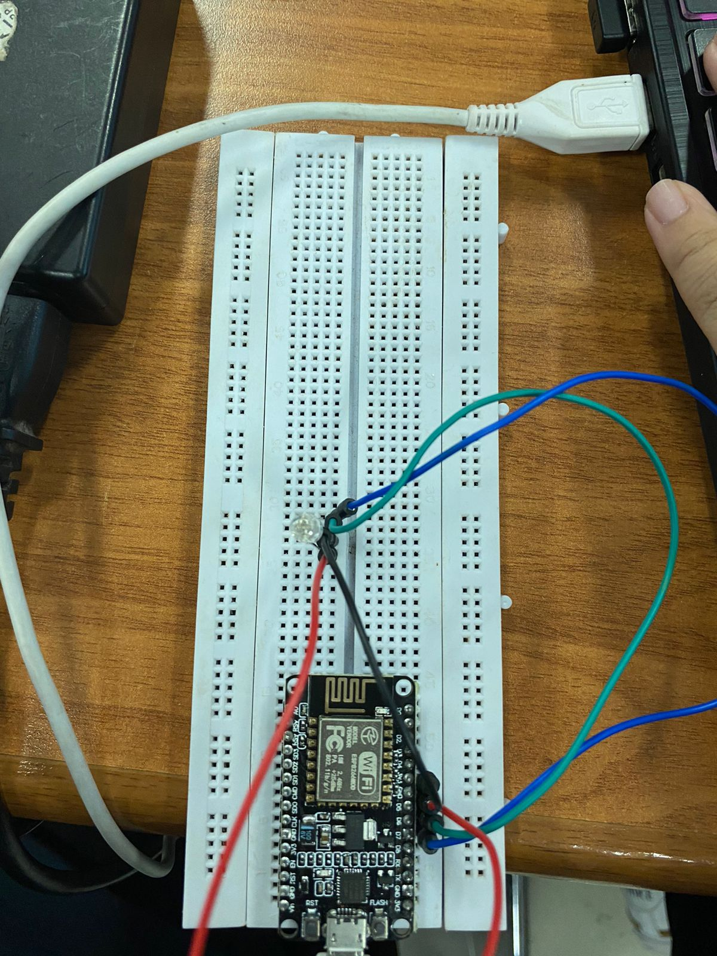



**Menggunakan SOS**

